**Station 1:**

1. **Finish the sentence: The altitude of Polaris equals one’s ___________________, but only in the __________________ hemisphere.**
2. **What is the observer’s latitude in the diagram below?**
3. **List 4 NYS cities in which this observer could be located (use pg. 3 of your ESRT!)**
4. **Where is the only place on Earth that Polaris is located at the *zenith*?**
5. **Where is the only place on Earth that Polaris is located on the horizon?**
6. **The fact that the altitude of Polaris changes with latitude provides evidence that the earth is _____________.**



1. Latitude, Northern
2. 43º N
3. Syracuse, Rochester, Niagara Falls, Utica
4. The North Pole/ 90 ºN
5. The equator
6. Round

**STATION 2**

**For the following coordinates, determine the correct city**

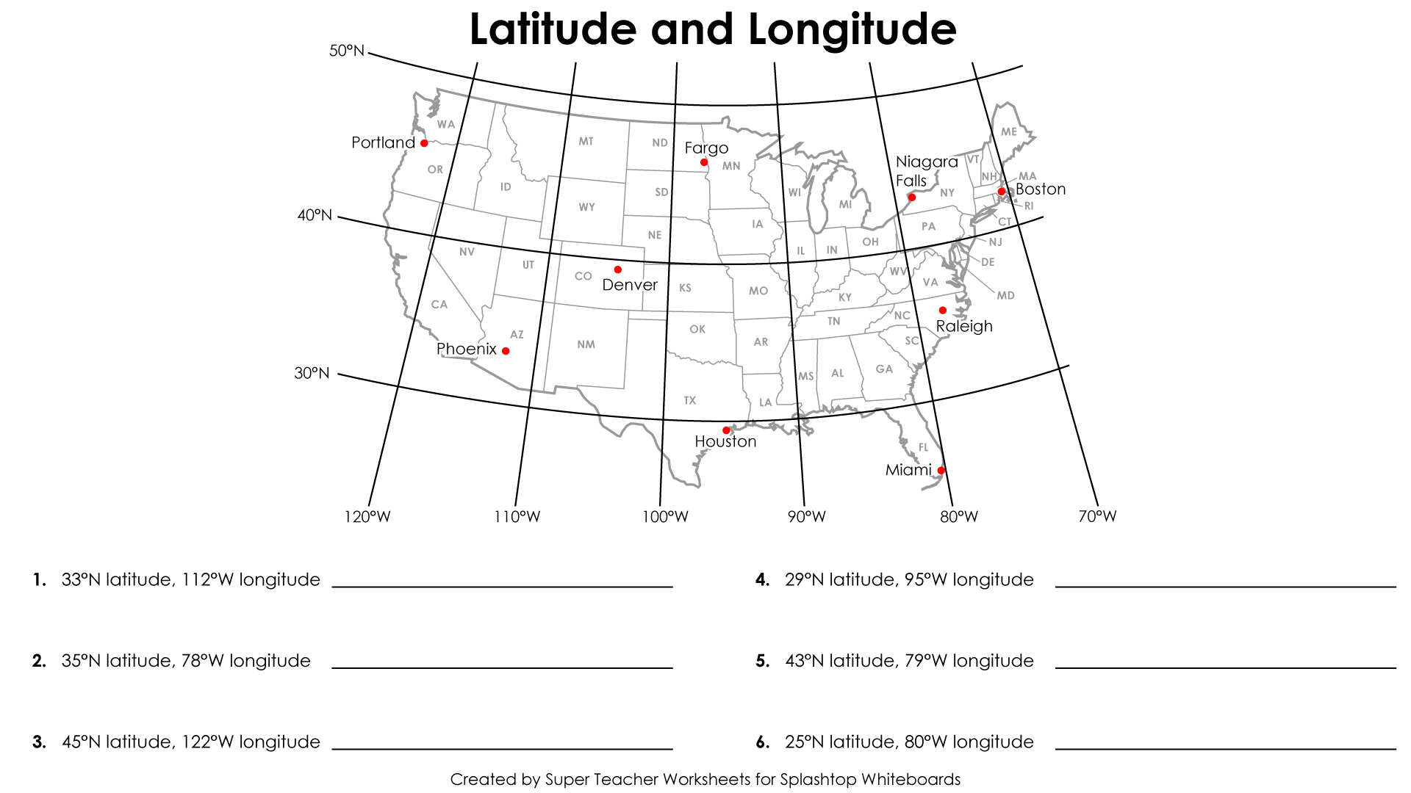

**7.) Earth Rotates from ____ to ______. (Compass Direction)**

**8.) At which location would the sun *set* *last?***

***9.)* At which location would the sun *rise* *first?***

1. Phoenix
2. Raleigh
3. Portland
4. Houston
5. Niagara Falls
6. Miami
7. West to East
8. Portland
9. Boston

**Station 3**

1. What is Earth’s Rate of Rotation (include units)?
2. A change in 15 degrees ___________(Longitude or latitude) will change one’s time by ______ hour(s).
3. If it is 3 p.m at location x, is it later in the day, or earlier in the day at location c?
4. What is the time difference, in hours, between location x and location C?
5. What is the time at location C, when it is 3 p.m. at location X?
6. What time is it at location A when it is 3p.m. at location X?
7. 15 º/hr
8. Longitude, 1 hour
9. Later in the day (traveled east)
10. 6 hours
11. 9 p.m.
12. 7 a.m.

**Station 4**

1. **What is the contour interval on this map?**
2. **What is the elevation of point Z?**
3. **What is the maximum elevation of Holland Hill?**
4. **What is the minimum elevation of Girard Hill?**
5. **What is the gradient from point Y to Z?**
6. **What is the elevation at the peak of Aurora Hill?**
7. 10 ft
8. *520 ft*
9. *569 ft*
10. *531 ft.*
11. *6.67 ft/mile*
12. *533 ft.*

**Station 5**

[](http://www.google.com/url?sa=i&rct=j&q=&esrc=s&frm=1&source=images&cd=&cad=rja&docid=5g9neKSHXl16rM&tbnid=EjRtGEAs4DTeNM:&ved=0CAUQjRw&url=http://academic.brooklyn.cuny.edu/geology/leveson/core/linksa/lat_long.html&ei=_CGKUqK2H8LJsQT51oBQ&bvm=bv.56643336,d.cWc&psig=AFQjCNFVF1_zbfZarUbNYjAveoCAQEqP5Q&ust=1384870710979989)

**Da Hood > .**

**Da Spot > .**

**For the following locations, estimate the coordinates in both degrees and minutes. Note that 30’ tick marks have NOT been draw on this map**

1. **What is the approximate coordinates of Da Place?**
2. **What is the approximate coordinates of Da Spot?**
3. **What is the approximate coordinates of Da Hood?**
4. **What is the most accurate representation of the earth’s shape?**
5. **What is the best piece of evidence that proves that earth is round?**
6. *5º40’ N, 71 º40’W*
7. *5 º30’ N, 70 º55’ W*
8. *5 º 15’N, 71 º45’ W*
9. *A sphere. In a model this is a globe*
10. *Satellite images taken from space*

***STATION 6***



1. **What is the elevation of the first contour line shown on this map?**
2. **In which direction is Mud Creek Flowing?**
3. **Give two pieces of evidence provided by the contour lines that explain the stream flow direction.**
4. **If you were to draw a general profile along A to B, what would it show?**
5. **What is a possible elevation at the source of Mud Creek?**
6. **If this island were a volcano that erupted, and the mountain peak blew off, what type of contour line would be drawn on the map to depict a depression? Write the symbol down.**
7. 0 ft.
8. SE/southeast
9. The contour lines bend and make a v which points NW/North West OR the contour lines show that elevation is increasing to the north west, therefore water flows downstream southeast
10. You would start at 20 ft, and gradually climb a hill at 134 ft, then you would descend back down to 20 ft, but at a steeper slope (greater gradient)
11. 101-119 ft
12. 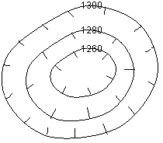 A hatchured contour line